REPUBLIQUE DU CAMEROUN
*****
Paix-Travail-Patrie
REPUBLIC OF CAMEROUN
*****
Peace-Work-Fatherland


AFRILAND FIRST BANK
Directions des Systèmes d’Information

Design and Implementation of a Software Development Automation Platform

DESIGN DOCUMENT

Presented by:
KOUETCHE SIMO Yann Jefferson
and
FORBIN Astera-Lainey Etonde
Engineering students in Computer Science and Information Systems
Academic Year 2025-2026
June 2026

SUMMARY
1. Introduction 1
2. Project Presentation 1
2.1 System Objectives 1
2.2 System Interfaces 2
2.3 System Constraints 3
3. Standards and Tools 4
3.1 Design Method 4
3.2 Development Environment and Tools 5
3.2.1 Hardware and Tools 5
3.2.2 Programming Standards 7
3.2.3 Quality Plan 7
4. General Design 8
4.1 System Modules and Responsibilities 8
1. User and Authentication Module 8
2. Project Management Module 9
3. Requirements Engineering Module 10
4. Context Management and RAG Module 11
5. Artificial Intelligence Integration Module 11
6. Document Generation Module 12
7. UML Modeling Module 13
8. Source Code Generation Module 14
9. Version Management Module 15
10. Deployment Automation Module 16
4.2 Component Diagram 18
4.3 Deployment Diagram 21
5. Detailed Design 24
5.1 Design Class Diagram 24
5.2 Detailed Class Diagrams per Service 25
6. Sequence Diagrams 36
7. Conclusion 49

TABLE OF ILLUSTRATIONS
Figure 1: Component diagram 20
Figure 2: Deployment diagram 23
Figure 3: Global Design class diagram 24
Figure 4: Auth service class diagram 25
Figure 5: Project service class diagram 26
Figure 6: Document generation class 27
Figure 7: Codegen Class 28
Figure 8: validation service 29
Figure 9: UML rendering service class 30
Figure 10: AI orchestrator class 31
Figure 11: RAG service class 32
Figure 12: Meta Model service 33
Figure 13: Meta Model Service Class 34
Figure 14: Version management service 34
Figure 15: Deployment package service 35
Figure 16: Sign Up Sequence Diagram 36
Figure 17: Log In Sequence Diagram 37
Figure 18: Create Project Sequence Diagram 38
Figure 19: Generate Requirements Sequence Diagram 39
Figure 20: Validate Requirements Sequence Diagram 40
Figure 21: Generate Diagrams Sequence Diagram 41
Figure 22: Validate Diagrams Sequence Diagram 42
Figure 23: Generate Documentation Sequence Diagram 43
Figure 24: Validate Documentation Sequence Diagram 44
Figure 25: Generate Code Sequence Diagram 45
Figure 26: Validate Code Sequence Diagram 46
Figure 27: Manage Versions Sequence Diagram 47
Figure 28: Generate Deployment package Sequence Diagram 48

Introduction
This document constitutes the design report for the sdlc automation platform. Its purpose is to define the technical architecture, design decisions, tools, standards and detailed conception of the system.
This document is organised as follows. It begins with a presentation of the project, covering the system objectives, external interfaces and general design constraints. It then describes the methods, tools and quality standards that govern the development process. It continues with the general design, covering the software modules, component diagram and deployment architecture. It concludes with the detailed design, covering the design class diagram, the application theme and the main interface mockups.

Project Presentation

System Objectives
The project is an intelligent web platform whose ambition is to automate the major phases of the software development lifecycle. Its fundamental principle is simple: a user submits a textual description of a software project, and the platform handles most of the engineering work that follows, from requirements analysis to the deployment of a functional application.
The specific objectives of the system are the following:
Objective 1: Intelligent requirements engineering. The system must be capable of reading a user's free-text description and uploaded specification document, analysing their content, identifying any missing information through guided questions, and producing a formal, structured list of software requirements that the user can validate or refine.
Objective 2: Automated system design. From the validated requirements, the system must automatically produce the full technical architecture of the application: the database schema, the class diagram, the API structure, and the page layout. This design must be presented to the user in a readable form and be open to revision before any code is produced.
Objective 3: Professional document generation. The system must produce all standard software engineering documents automatically and in a format consistent with the validated requirements and design. These documents must be indexable for AI memory and downloadable as Word files.
Objective 4: Full-stack code generation. The system must generate a complete, functional web application codebase comprising a Spring Boot backend, an Angular frontend, a MySQL database setup, a security layer based on JWT, and unit and integration tests. The generation must use FreeMarker and Mustache templates for structural consistency and AI for business logic insertion. The code must be automatically validated and self-corrected before being delivered to the user.
Objective 5: Interactive validation and regeneration. At every stage of the pipeline (requirements, design, documents and code) the user must be able to validate the output or request targeted changes by writing plain-language instructions. The system must interpret these instructions and regenerate the affected content accordingly.
Objective 6: Version management. Every generation and regeneration of the codebase must be automatically saved as a numbered version snapshot. The user must be able to browse the full history, compare any two versions, restore any past version and download the code of any version at any time.
Objective 7: One-click local deployment. The system must produce a Docker-based deployment package containing a docker-compose.yml, a pre-filled .env file and a README with step-by-step instructions. The user must be able to run their application locally with a single terminal command, with no technical prerequisites beyond Docker Desktop

System Interfaces
This project interacts with the following external services:
- Anthropic Claude API: The backend shall communicate with the Anthropic Claude API via HTTPS POST requests to the endpoint.
- MySQL 8 Database: The backend shall communicate with the MySQL database via JDBC through Spring Data JPA and Hibernate. All database credentials shall be stored in environment variables.
- Kroki Diagram Rendering API: The backend shall send PlantUML diagram source code to the Kroki HTTP endpoint and receive rendered PNG or SVG images in return.
- Apache POI and PDFBox: These libraries shall be used internally by the backend to extract text content from uploaded Word and PDF documents respectively, without any external network communication.
- JavaMail / SMTP: The backend shall use JavaMail to send emails via an SMTP server. The SMTP host, port, username and password shall be stored as environment variables.
- Docker Registry: The generated docker-compose.yml shall reference the user's Docker credentials for image management. This interface is used by Docker on the user's local machine, not by the Astyann server.

System Constraints
- Data Protection and Privacy: The platform stores sensitive user data including email addresses, hashed passwords and the content of uploaded specification documents. Any leakage and the user can take the company to court.
- AI Model Dependency: The platform's core functionality depends on the availability and reliability of the AI API. Any outage or rate limiting on this external service directly impacts the platform's ability to generate requirements, designs, documents and code.
- Generated Code Consistency: Because the codebase is generated across multiple sequential AI calls (backend, frontend, database, security, tests) all calls must share the same project context. The RAG Store is the mechanism that enforces this consistency.
- Version Storage Constraints Each version snapshot stores a full ZIP of the generated codebase in the database. As users iterate through multiple versions, the storage footprint per project grows. The system must account for this in its database design and consider compression strategies to keep ZIP sizes manageable.
- User Technical Prerequisites The platform is designed for users with some programming knowledge. All instructions related to this must be clear, non-technical and accompanied by a direct download link in the README.
- Template Maintenance The FreeMarker and Mustache templates used during code generation represent a critical asset of the platform. Any bug in a template affects every project that uses it. Templates must be version-controlled, tested independently from the AI generation pipeline, and updated carefully whenever the target framework versions change.

Standards and Tools

Design Method

Modeling Approach
The development methodology or modelling methodology adopted for the project combines the 2TUP (Two Tracks Unified Process) methodology with an Agile development approach during the implementation phases of the project.
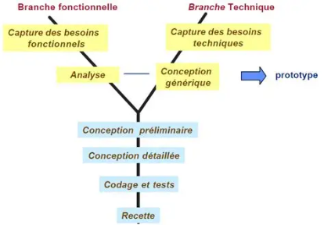
This methodological choice was made because the project simultaneously involves functional analysis activities, technical organization activities, intelligent processing mechanisms, and progressive feature development. The combination of 2TUP and Agile allows the project to maintain strong organizational structure while remaining flexible enough to adapt to evolving project needs throughout development.
The functional track focuses on understanding and modeling the business needs of the system. The technical track focuses on the organization of the solution itself. Separating these two tracks at the beginning of the project reduces confusion between business concerns and implementation concerns.
After the convergence phase, the project transitions into an Agile development approach based on iterative and incremental development cycles.
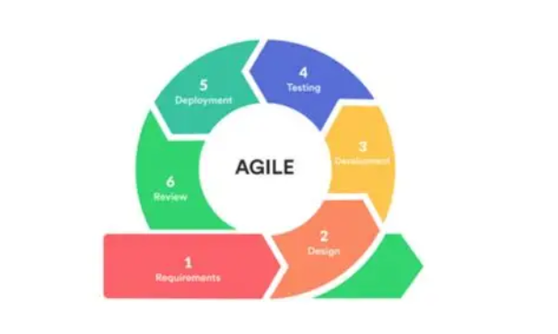
The Agile approach provides several important advantages for the project. It allows functionalities to be developed progressively, facilitates continuous validation of generated outputs, supports rapid integration of feedback, and improves the adaptability of the project when requirements evolve during development. The iterative nature of Agile also helps reduce project risks by ensuring that corrections and improvements can be integrated continuously rather than only at the end of development.

Modeling Language
The modeling language selected for the project is UML (Unified Modeling Language) which was chosen because it is one of the most widely recognized and standardized modeling languages in software engineering. It provides a clear and structured way of representing system behavior, interactions, workflows, and organizational structures.

Development Environment and Tools

Hardware and Tools
Backend Framework: The backend of the generated applications is built using Spring Boot 3.x. Spring Boot provides auto-configuration, embedded server support and a rich ecosystem of libraries for REST API development, security and database access. It was chosen for its maturity, its widespread adoption in enterprise software, and the quality of its code generation support via FreeMarker templates.
Frontend Framework: The frontend of the generated applications is built using Angular 17. Angular is a complete, opinionated framework that provides a consistent project structure, strong typing via TypeScript, and a component-based architecture well suited to template-based generation with Mustache. Its predictable file structure makes it ideal for automated code generation.
Programming Language: Java 17 is used for the Spring Boot backend due to its long-term support status and compatibility with the Spring ecosystem. TypeScript is used for the Angular frontend for its strong typing, which reduces generation errors and improves code quality.
Database: MySQL 8 is used as the relational database management system for both the Astyann platform itself and for the generated applications. MySQL was chosen for its reliability, widespread use, and native compatibility with Spring Boot via Spring Data JPA and Hibernate.
Template Engines: FreeMarker is used for generating the Spring Boot backend skeleton, including configuration files, pom.xml, application.properties and structural class files. Mustache is used for generating the Angular frontend components, services, models and routing files. Both engines allow the separation of structural boilerplate from AI-generated business logic.
AI Interface: All AI operations are performed via the Anthropic Claude API. The API is called from the backend AI Module via HTTPS REST requests. The claude-sonnet model was selected for its strong performance on code generation, instruction following and long-context document processing tasks.
RAG Implementation: The RAG Store Module is implemented using Spring AI, which provides native integration with vector stores and embedding models. Documents are chunked, embedded and stored in a vector database. At generation time, the most semantically relevant chunks are retrieved and injected into the AI prompt as context.
Build Tool: Maven is used as the build and dependency management tool for the platform’s backend. It provides a standardised project structure, dependency resolution and build lifecycle management compatible with Spring Boot.
Containerisation: Docker is used to containerise the generated applications for local deployment. Docker Compose is used to orchestrate the multi-container setup (backend, frontend, database). The deployment package generated by the platform contains a docker-compose.yml and a .env file that allows the user to run their application with a single command.
Version Control: Git is used internally by the development team for source code version control. The platform itself implements its own snapshot-based versioning system for generated codebases, independent of Git.
IDE: IDEA IntelliJ IDEA is the integrated development environment for the patform’s backend development, providing native support for Java, Spring Boot, Maven and database tools.
API Testing: Postman is used for testing and documenting the REST API during development.

Programming Standards
REST API Design All backend endpoints follow RESTful design principles. Resources are named using nouns in lowercase with hyphens (e.g. /projects/:id/requirements). HTTP methods are used semantically: GET for retrieval, POST for creation, PUT for full updates, PATCH for partial updates and DELETE for removal. All responses follow a consistent JSON envelope structure including a status code, a message and a data payload.
Code Organisation The backend follows a layered architecture: Controller → Service → Repository → Entity. Each module has its own package. No business logic is placed in controllers. No database queries are placed in service classes — all data access goes through repository interfaces.
Security Standards All passwords are hashed using BCrypt. JWT tokens are signed using HS256 and have a configurable expiry time. All API endpoints except /auth/register and /auth/login require a valid JWT token in the Authorization header. Sensitive configuration values (database passwords, API keys, JWT secrets) are stored in environment variables and never hardcoded.

Quality Plan
The quality of the platform is governed by the processes described by the ISO/IEC 12207 standard, whose mission is to provide a framework for the management of software quality across the full software lifecycle.
The quality plan is structured as follows:
Software Quality Assurance (SQA) — IEEE 730 A Software Quality Assurance process is applied throughout the project in accordance with the IEEE 730 standard. This includes the systematic review of all deliverable documents, the verification that the implemented system conforms to its specifications, and the enforcement of the coding standards.
Verification and Validation (V&V) — IEEE 1059 Verification and Validation activities are conducted in accordance with the IEEE 1059 standard. Verification ensures that each module is built correctly according to its design specification. Validation ensures that the complete system satisfies the user requirements defined in the SRS. Both unit testing and integration testing are used as V&V mechanisms.
Reviews and Audits — IEEE 1028 Formal reviews are conducted at the end of each major development phase in accordance with the IEEE 1028 standard. These include design reviews before implementation begins, code reviews before any module is merged into the main branch, and a final system review before delivery.
Risk Management — ISO 27005 Risks are identified, assessed and monitored in accordance with the ISO 27005 standard. The main risks identified for the project are the following: dependency on the Anthropic Claude API availability; inconsistency in AI-generated code across multiple generation calls; storage growth from version snapshot accumulation; and the complexity of maintaining FreeMarker and Mustache templates across framework version updates.

General Design

System Modules and Responsibilities
The platform is organized into several collaborating modules. Each module groups together related business entities and services that participate in a specific phase of the software development automation lifecycle. This modular decomposition is derived directly from the business entities identified during the analysis phase and reflected in the business class diagram.

1. User and Authentication Module
Purpose
This module manages user accounts, authentication, authorization, and account verification. It serves as the entry point to the platform and ensures that only authenticated users can access project generation services.
Main Entities
- User
Entity Description
The User entity represents an authenticated platform user responsible for creating and managing software generation projects.
Attributes
- userId
- email
- password
- is_verified
- verification_code
- verification_expiry_date
- created_at
- last_login
Responsibilities
- User registration
- User authentication
- Email verification
- Password management
- Session management
- Access control

2. Project Management Module
Purpose
This module manages software development projects throughout their lifecycle. It acts as the central workspace where all generated artifacts are stored and organized.
Main Entities
- Project
Entity Description
The Project entity represents a software development project and acts as the central aggregation point for requirements, diagrams, documents, generated code, deployment packages, and version history.
Attributes
- projectId
- title
- description
- creation_date
- updated_date
- status
- doc_path
- doc_url
Responsibilities
- Project creation
- Project management
- Project tracking
- Artifact organization
- Workflow progression management

3. Requirements Engineering Module
Purpose
This module handles requirement extraction, clarification, validation, and storage. It transforms raw user specifications into structured software requirements.
Main Entities
- Requirements
- GuidedQuestions
Requirements Entity
Represents a functional or non-functional requirement used as a basis for all subsequent generation activities.
Attributes
- reqId
- title
- description
- type
- generated_date
GuidedQuestions Entity
Represents clarification questions generated by the platform to collect additional information from the user.
Attributes
- GQ_Id
- question
- answer
Responsibilities
- Requirement extraction
- Requirement storage
- Requirement validation
- Requirement refinement
- Clarification question management

4. Context Management and RAG Module
Purpose
This module maintains the project's contextual knowledge repository and supports retrieval-augmented generation throughout the platform.
Main Entities
- ReferenceContext
Entity Description
ReferenceContext stores indexed project knowledge extracted from requirements, documents, diagrams, and generated artifacts.
Responsibilities
- Knowledge indexing
- Context storage
- Semantic retrieval
- Retrieval-Augmented Generation (RAG) support
- Context enrichment for AI generation
The module ensures consistency between generated artifacts by providing relevant contextual information to generation services.

5. Artificial Intelligence Integration Module
Purpose
This module acts as the centralized gateway between the platform and external Large Language Models (LLMs).
Main Entities
- AIService
Attributes
- providerName
- modelName
- apiKey
Responsibilities
- Requirement analysis
- Document generation assistance
- UML generation assistance
- Source code generation assistance
- Deployment artifact generation
- Prompt orchestration
- Response processing
This module is used by all generation engines of the platform.

6. Document Generation Module
Purpose
This module automatically produces software engineering documentation based on project requirements and contextual information.
Main Entities
- DocumentGenerator
- Template
- Document
Template Entity
Represents reusable document templates.
Attributes
- templateId
- name
- type
- content
Document Entity
Represents generated software engineering documents.
Attributes
- documentId
- type
- path
- URL
- generatedDate
DocumentGenerator Entity
Responsible for orchestrating document production using templates and AI services.
Attributes
- templateEngine
Responsibilities
- SRS generation
- Functional analysis generation
- Design document generation
- API documentation generation
- User manual generation
- Deployment guide generation
- Template management

7. UML Modeling Module
Purpose
This module automatically generates UML models representing different views of the system.
Main Entities
- UMLGenerator
- UMLDiagram
UMLDiagram Entity
Represents a generated UML diagram and its associated PlantUML source code.
Attributes
- diagramId
- type
- generatedImageURL
- generatedDate
- source_code
Responsibilities
- Use case diagram generation
- Activity diagram generation
- Sequence diagram generation
- Class diagram generation
- Component diagram generation
- Deployment diagram generation
- Entity-relationship diagram generation
- Diagram rendering

8. Source Code Generation Module
Purpose
This module generates the complete software application based on validated requirements, documents, and diagrams.
Main Entities
- CodeGenerator
- GeneratedCode
GeneratedCode Entity
Represents generated source code artifacts.
Attributes
- codeId
- code_url
- code_path
- gen_date
- layer
- downloadUrl
Responsibilities
- Backend generation
- Frontend generation
- Database generation
- Security layer generation
- Configuration generation
- Automated validation and correction
- Packaging of generated source code

9. Version Management Module
Purpose
This module provides complete traceability of generated artifacts by maintaining historical versions of project outputs.
Main Entities
- Timeline
- Snapshot
- DocumentSnapshot
- DiagramSnapshot
- CodeSnapshot
- DeploymentSnapshot
Timeline Entity
Represents the version history of a project.
Attributes
- timelineId
- creationDate
Snapshot Entity
Abstract entity representing a versioned artifact.
Attributes
- snapId
- versionName
- versionNumber
- snapDate
- entrySource
Responsibilities
- Automatic version creation
- Version history storage
- Version restoration
- Traceability management
- Artifact evolution tracking

10. Deployment Automation Module
Purpose
This module prepares the generated application for execution by automatically creating deployment resources and packaging them into deployable archives.
Main Entities
- DeploymentPackage
- DockerPackage
- EnvFile
- READMEFile
DeploymentPackage Entity
Represents the complete deployment bundle generated by the platform.
Attributes
- packageId
- name
- creationDate
DockerPackage Entity
Represents Docker configuration resources.
Attributes
- dockerPackageId
- path
- URL
EnvFile Entity
Represents environment configuration files.
Attributes
- envId
- path
- URL
READMEFile Entity
Represents deployment instructions generated for the user.
Attributes
- fileId
- path
- URL
Responsibilities
- Docker configuration generation
- Environment file generation
- Deployment documentation generation
- ZIP packaging
- Deployment artifact management
- Application delivery preparation
The User and Authentication Module provides access to the platform and allows users to create Projects. Requirements Engineering extracts and structures project requirements, which are indexed into the ReferenceContext. The AIService uses this contextual knowledge to support Document Generation, UML Modeling, Source Code Generation, and Deployment Automation. All generated artifacts are versioned through the Version Management Module, ensuring complete traceability and allowing users to restore previous project states whenever necessary.

Component Diagram
The component diagram illustrates the architectural assembly of the platform across nine distinct tiers, each with clearly defined responsibilities and interfaces.
Client and Entry Routing: The User interacts with the platform exclusively through the Angular Web Client. All requests are forwarded synchronously to the API Gateway (Spring Boot), which acts as the single entry point to the backend. The gateway dispatches incoming calls to the Auth Module, Project Module, Validation Module, Requirement Module, Version Management Module, and AI Orchestrator Module via their respective provided interfaces: IAuth, IProject, IValidation, IRequirement, IVersionManager, and IAIOrchestrator.
Core Services: The Auth Module and Project Module each own a dedicated MySQL database, strictly following the Database-per-Service principle. No service accesses another service's database directlyall cross-service communication passes through exposed interfaces. The Validation Module is intentionally stateless: it exposes the IValidation interface but owns no database, in accordance with its pure constraint evaluation responsibility. Upon project creation, the Project Management component triggers the Requirement Analysis Service via IRequirement.
Requirement Engineering: The Requirement Analysis Service is the platform's first major intelligence stage. It receives the parsed specification document and guided question responses, then calls the AI Orchestrator via IAIOrchestrator to produce a structured list of functional and non-functional requirements. These requirements are persisted in a dedicated MySQL database and indexed into the RAG Knowledge Base via IRAGService, establishing the semantic foundation for all downstream generation. Upon user approval, the Requirement Analysis Service triggers the Document Generation Engine, UML Generation Service, and Code Generation Engine via their respective interfaces.
Generation Layer. The generation layer comprises four specialized services. The Document Generation Engine and the Code Generation Engine each own a dedicated MySQL database for persistence. All four generation services; Document, UML, Code, and Deployment communicate with the AI Orchestrator via IAIOrchestrator to enrich their outputs with AIassisted content. After each successful generation or regeneration, every service notifies the Version Management Service via IVersionManager to create a new snapshot. Generated documents and UML diagrams are written to Document Storage; generated source code is written to Code Storage; deployment artifacts are written to Deployment Storage.
Deployment Automation. The Deployment Automation Service is triggered after code validation. It calls the AI Orchestrator to generate a docker-compose.yml, a pre-filled .env configuration file, and a README.md with step-by-step run instructions. These three artifacts are composed into a DeploymentPackage, persisted in the Deployment Database, packaged as a downloadable ZIP archive, and written to Deployment Storage. Upon completion, it notifies the Version Management Service to record a DeploymentSnapshot.
Version Management. The Version Management Service is responsible for the complete lifecycle of versioned artifacts across the platform. It owns a dedicated MySQL database storing Timeline records and all snapshot variants; DocumentSnapshot, DiagramSnapshot, CodeSnapshot, and DeploymentSnapshot. It is notified by all four generation services after each generation or regeneration event, and automatically creates a timestamped, uniquely identified snapshot entry linked to the produced artifact. It exposes the IVersionManager interface, consumed both by the API Gateway for user facing operations (timeline browsing, version restoration, ZIP download of any past version) and by all generation services for automatic snapshot recording. To serve ZIP archive downloads for any historical version, it reads artifact content from Document Storage, Code Storage, and Deployment Storage.
AI Orchestrator. The AI Orchestrator acts as the central coordination hub for all AI interactions across the platform. It retrieves semantically relevant context from the RAG Knowledge Base via IRAGService, applies Meta Model schemas via IMetaModel to ensure structural conformity, then dispatches enriched prompts to external providers Anthropic Claude and OpenAPI, over HTTPS. No other platform component communicates directly with external AI providers.
Knowledge Layer. The RAG Module maintains the platform's semantic memory through a ChromaDB vector database, enabling similarity-based retrieval of indexed requirements, documents, and templates. The Meta Model Module owns a dedicated MySQL database and defines the canonical structural representation of each project; it reads templates from Template Storage and exposes the IMetaModel interface consumed by both the AI Orchestrator and the Validation Engine.
Storage Layer. The Storage Layer comprises four dedicated units: Document Storage (for generated documents and rendered UML diagrams), Code Storage (for generated application source code), Template Storage (for document and code generation templates), and Deployment Storage (for generated deployment packages and ZIP archives). Generation services write to these units; the Version Management Service reads from them to compose historical ZIP archives; the RAG Module indexes from them to maintain the platform's semantic knowledge base.
External APIs. External capabilities are provided exclusively by Anthropic Claude and OpenAPI, both accessed through the AI Orchestrator via HTTPS API calls.

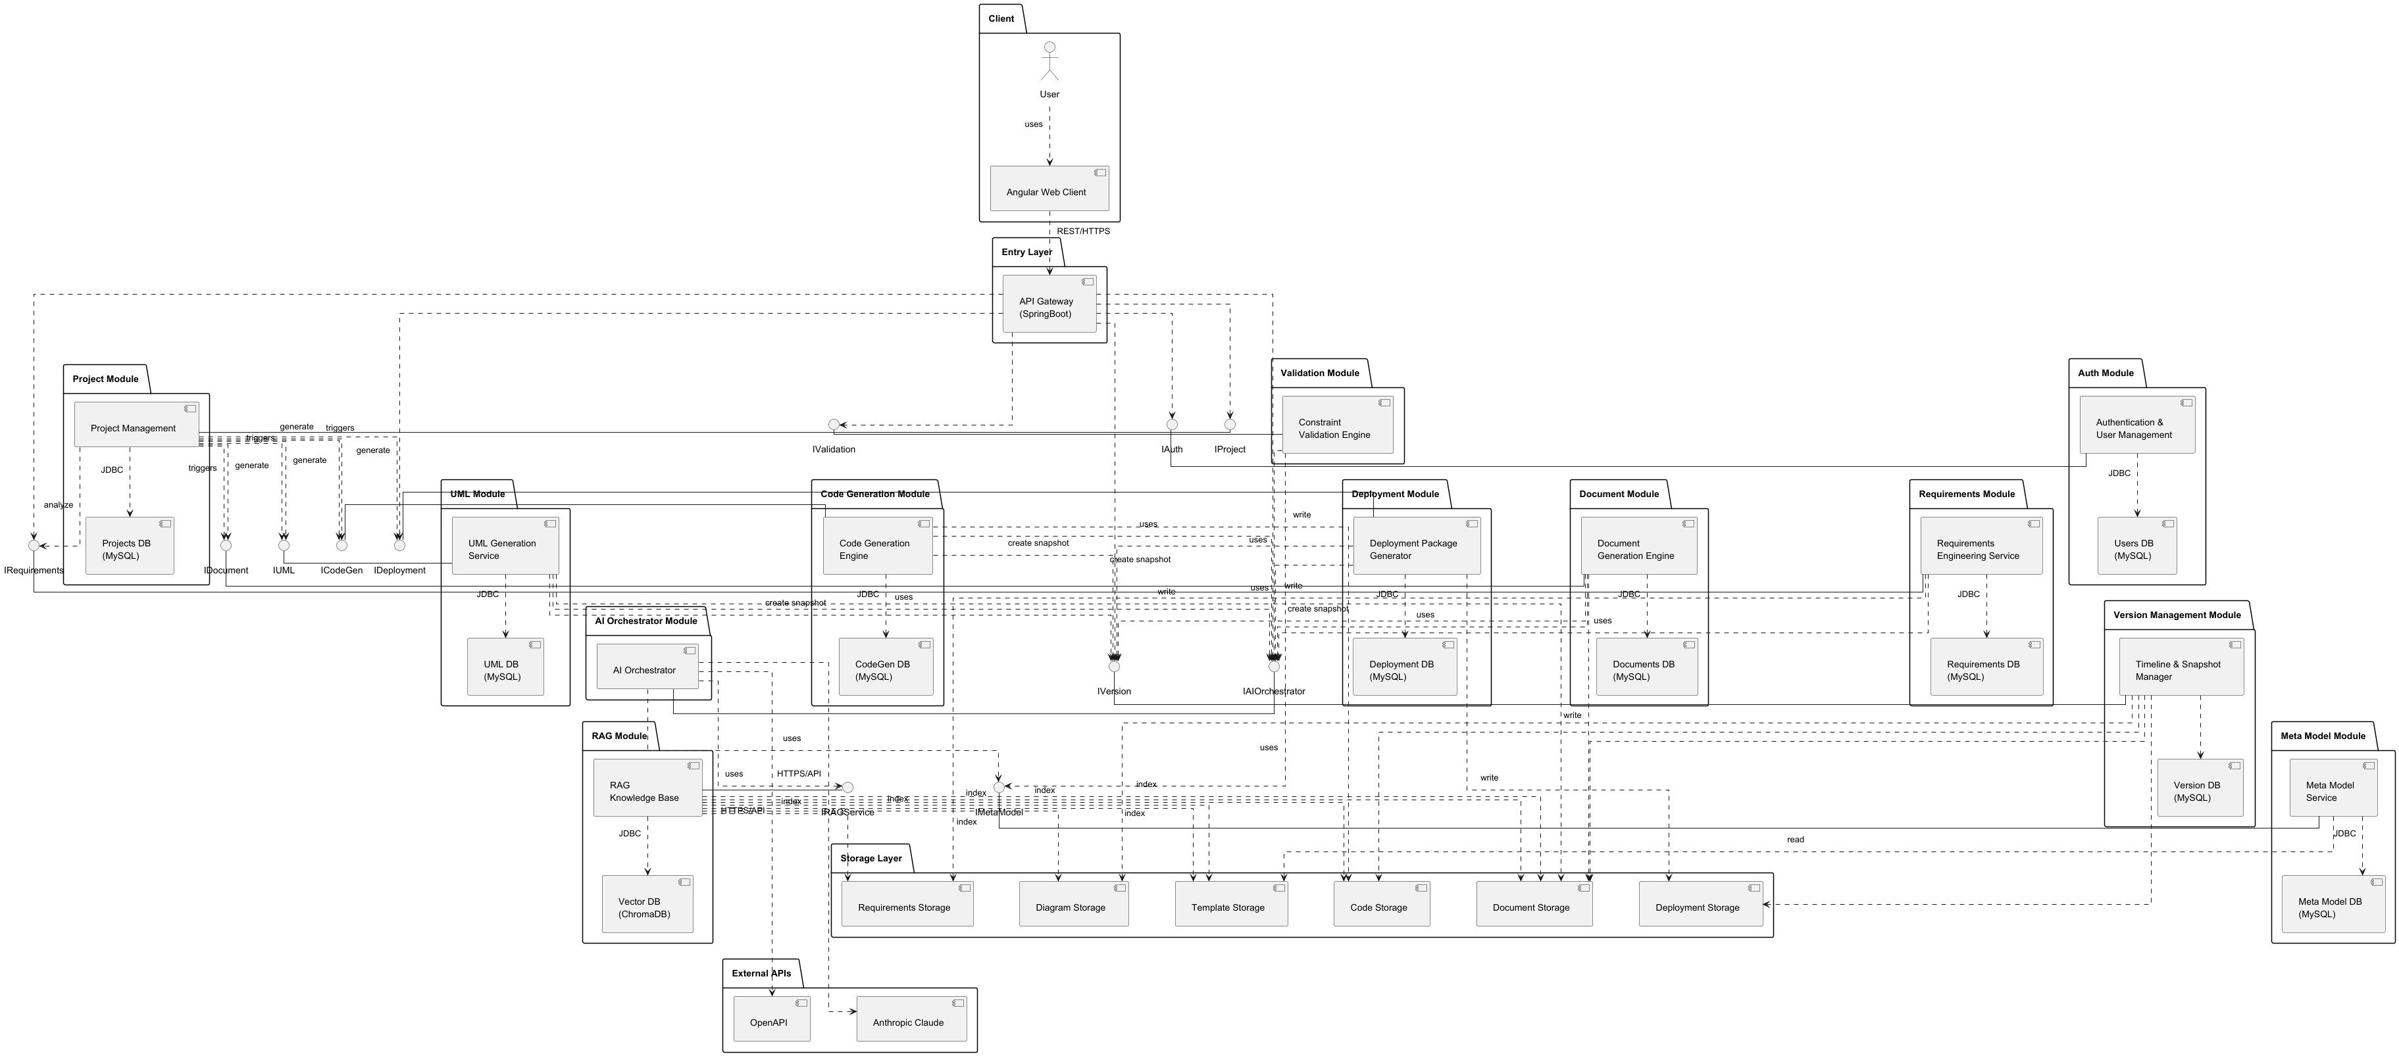
Figure 1: Component diagram

Deployment Diagram
The deployment diagram presents the physical distribution of the platform software architecture across a cloud infrastructure organized into four major execution environments: the User Machine, the Docker Host, the Database Host, and the Storage Host, complemented by several external services that support artificial intelligence, diagram rendering, and version control operations.
User Machine: The client tier consists of a standard web browser running on the user's machine. Users interact with the platform entirely through a web interface without requiring any local software installation. All communication between the browser and the platform occurs through secure HTTPS connections. The Angular frontend is served remotely by the platform and provides access to project management, requirements engineering, document generation, diagram generation, code generation, version management, and deployment functionalities.
Docker Host: The computational core of the platform is deployed on a cloud virtual machine running Docker Engine. This host contains all business and AI-related services organized into two logical layers.
The API Layer hosts the Spring Boot Backend, which acts as the central entry point for all client requests. Inside this backend are the major business modules of the platform: Authentication Management, Project Management, Requirement Management, Diagram Management, Document Management, Code Generation, Code Validation, Version Management, Deployment Management, and the AI Orchestrator. These modules expose REST endpoints and coordinate all platform workflows. The AI Orchestrator serves as the central coordinator responsible for directing generation and validation tasks to the appropriate AI services.
The AI Generation Layer contains specialized generation services responsible for producing software engineering artifacts. These include the Requirement Generator, Diagram Generator, Document Generator, Code Scaffold Generator, Code Generation Generator, Deployment Generator, Validation Engine, and the RAG Service. Each generator focuses on a specific stage of the software development lifecycle and operates independently under the supervision of the AI Orchestrator. This separation isolates computationally intensive AI workloads from deterministic business operations while improving scalability and maintainability.
Database Host: A dedicated database server stores all persistent platform information following the database per domain principle. The host contains several independent databases, each responsible for a specific category of information.
The Users Database stores account information, authentication data, and security credentials. The Projects Database maintains project metadata and lifecycle information. The Requirements Database stores generated and validated requirements. The Diagrams Database contains generated UML diagrams and their associated PlantUML source code. The Documents Database stores generated project documentation. The Code Database stores generated source code metadata and references. The Versions Database maintains version history, snapshots, and restoration information. The Deployments Database stores deployment packages and deployment-related metadata. Finally, the Vector Database, implemented using ChromaDB, stores semantic embeddings used by the Retrieval Augmented Generation (RAG) system.
Each module communicates exclusively with its own database. No module accesses another module's database directly. All inter-module communication is performed through the backend service layer, ensuring loose coupling, security, and clear ownership of data. Access to the Database Host is restricted through secure internal network connections and authenticated credentials.
Storage Host: A dedicated storage server provides persistent file storage for all generated and uploaded artifacts. The storage infrastructure is organized into several logical folders.
The Uploaded Documents repository stores user-provided specification documents and project resources. The Generated Documents repository contains all automatically generated software engineering documents such as Software Requirement Specifications, analysis documents, design documents, API contracts, deployment guides, and user manuals. The Generated Diagrams repository stores rendered UML diagrams and diagram exports. The Generated Code repository stores generated application source code and project archives. The Deployment Packages repository stores generated deployment ZIP packages containing Docker Compose configurations, environment files, and deployment instructions. Finally, the Templates repository contains reusable document templates, code generation templates, scaffolding structures, and other resources consumed by generation services.
Like the Database Host, the Storage Host is accessible only through the platform's private network and is never directly exposed to public internet traffic.
External Services.
The platform integrates several external services required for advanced generation and collaboration capabilities.
The Claude API and OpenAPI provide large language model capabilities used for requirements generation, document generation, UML generation, code generation, deployment package generation, and validation tasks. These services are accessed exclusively by the specialized AI generators through secure HTTPS communication.
The Kroki Rendering Service is used by the Diagram Generator to convert PlantUML source code into visual UML diagrams in SVG or PNG format. This allows generated diagrams to be rendered without requiring a local rendering engine.
Overall, the deployment architecture separates presentation, business logic, artificial intelligence processing, persistence, storage, and external integrations into distinct deployment environments. This separation improves scalability, maintainability, fault isolation, security, and performance while supporting the intensive generation workflows required by the Astyann software development automation platform.

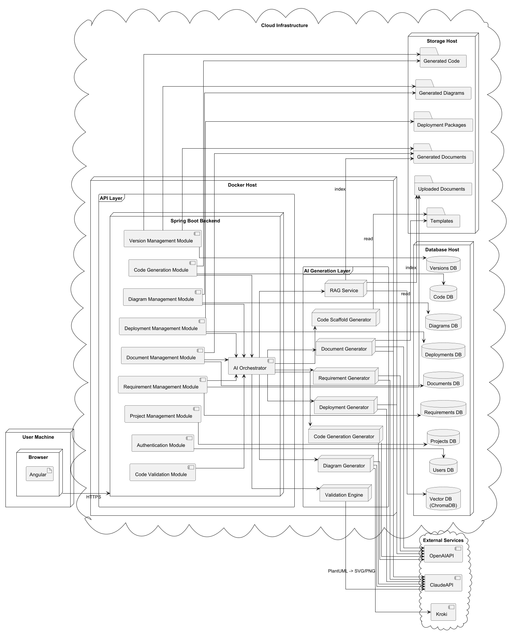
Figure 2: Deployment diagram

Detailed Design

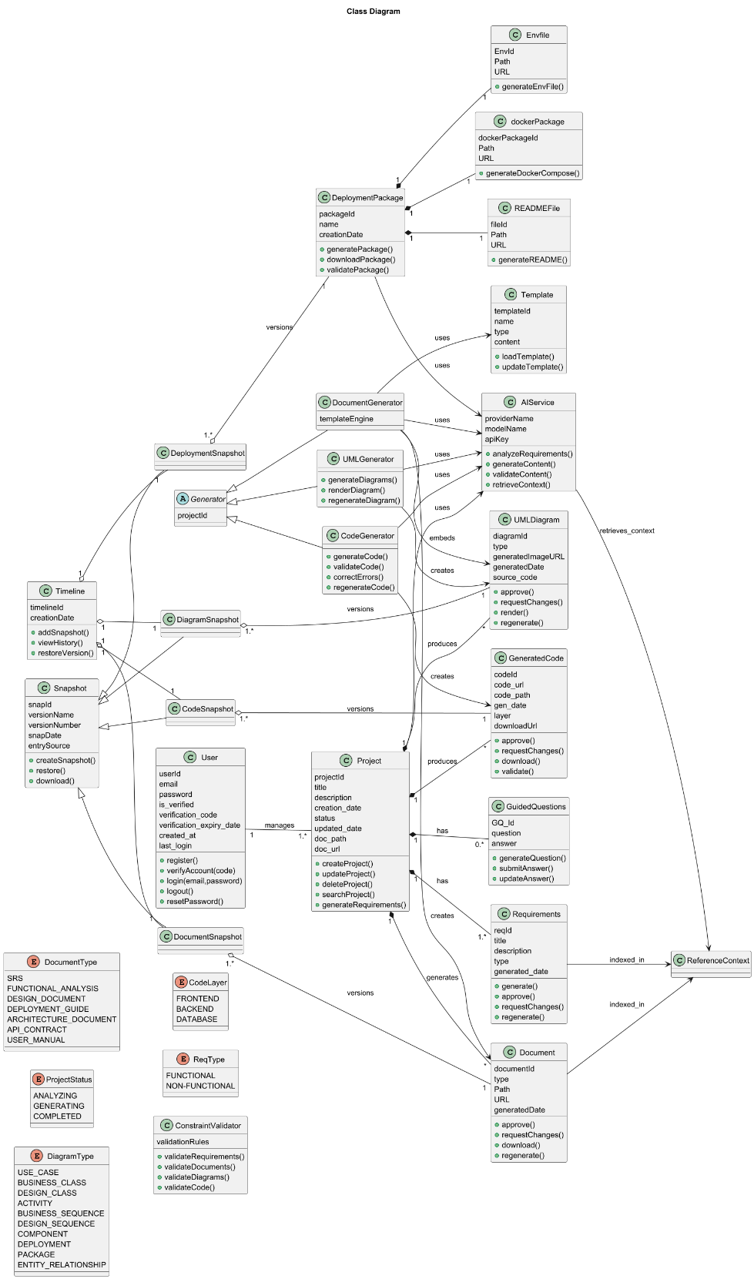
Design Class Diagram
Figure 3: Global Design class diagram

Detailed Class Diagrams per Service
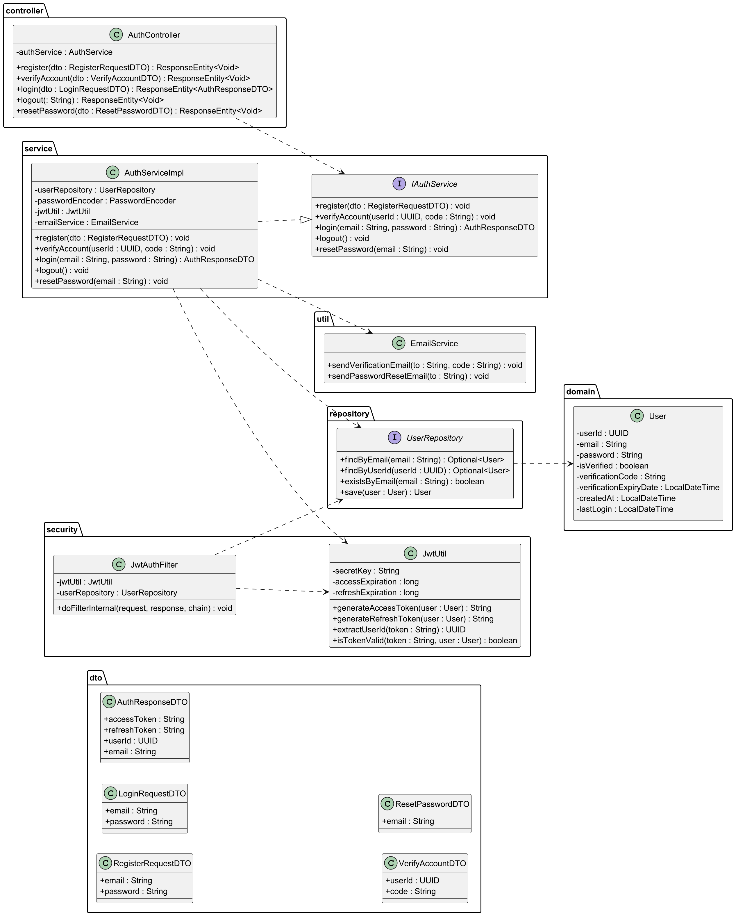
    - Auth Service
Figure 4: Auth service class diagram
    - Project Service
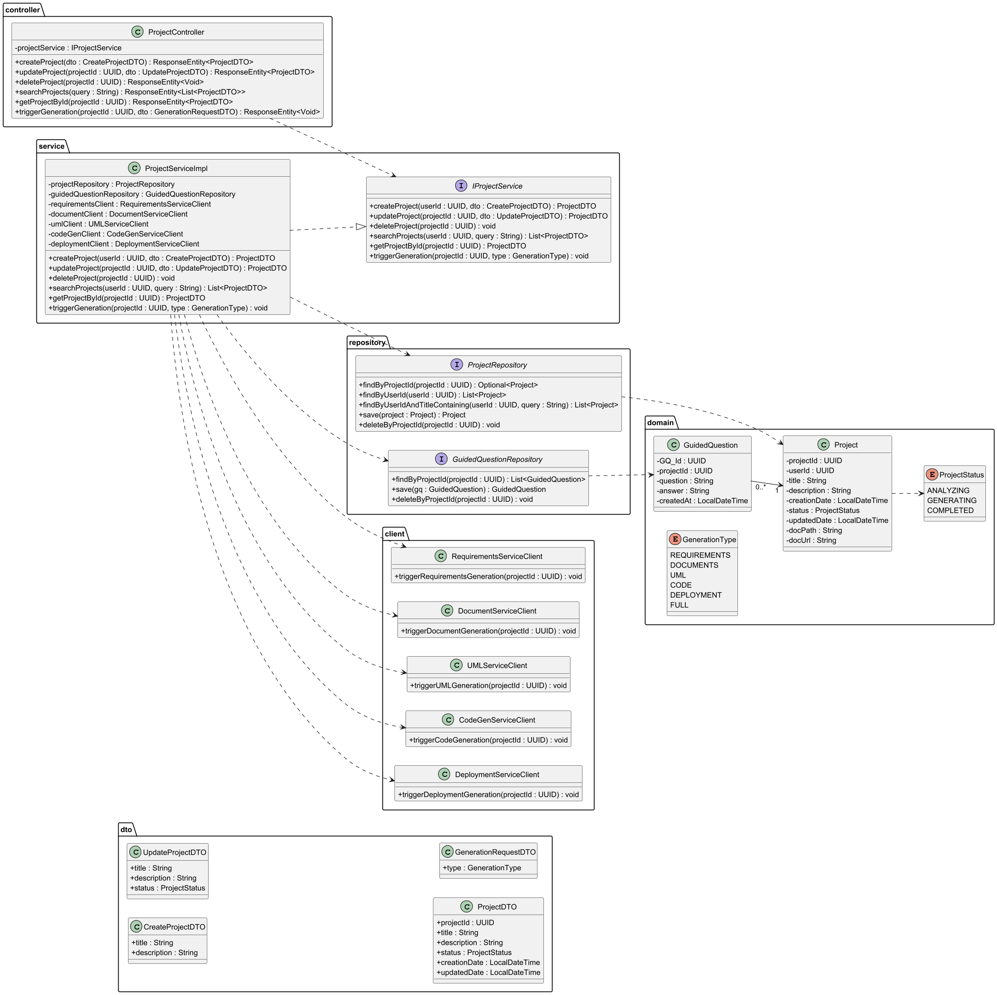
Figure 5: Project service class diagram

    - Document Service
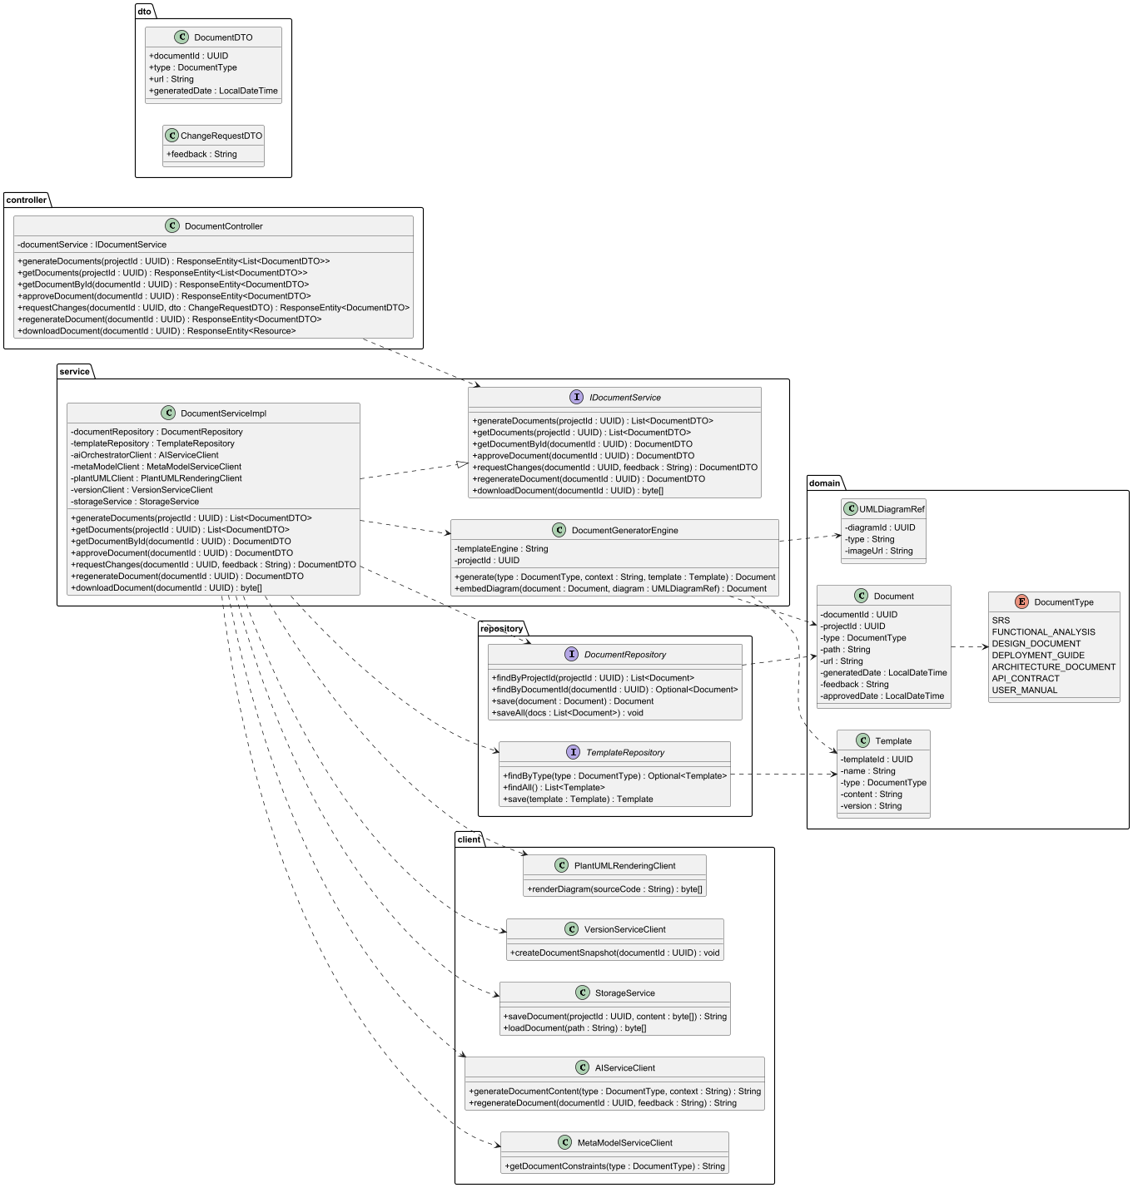
Figure 6: Document generation class

    - Code Generation Service
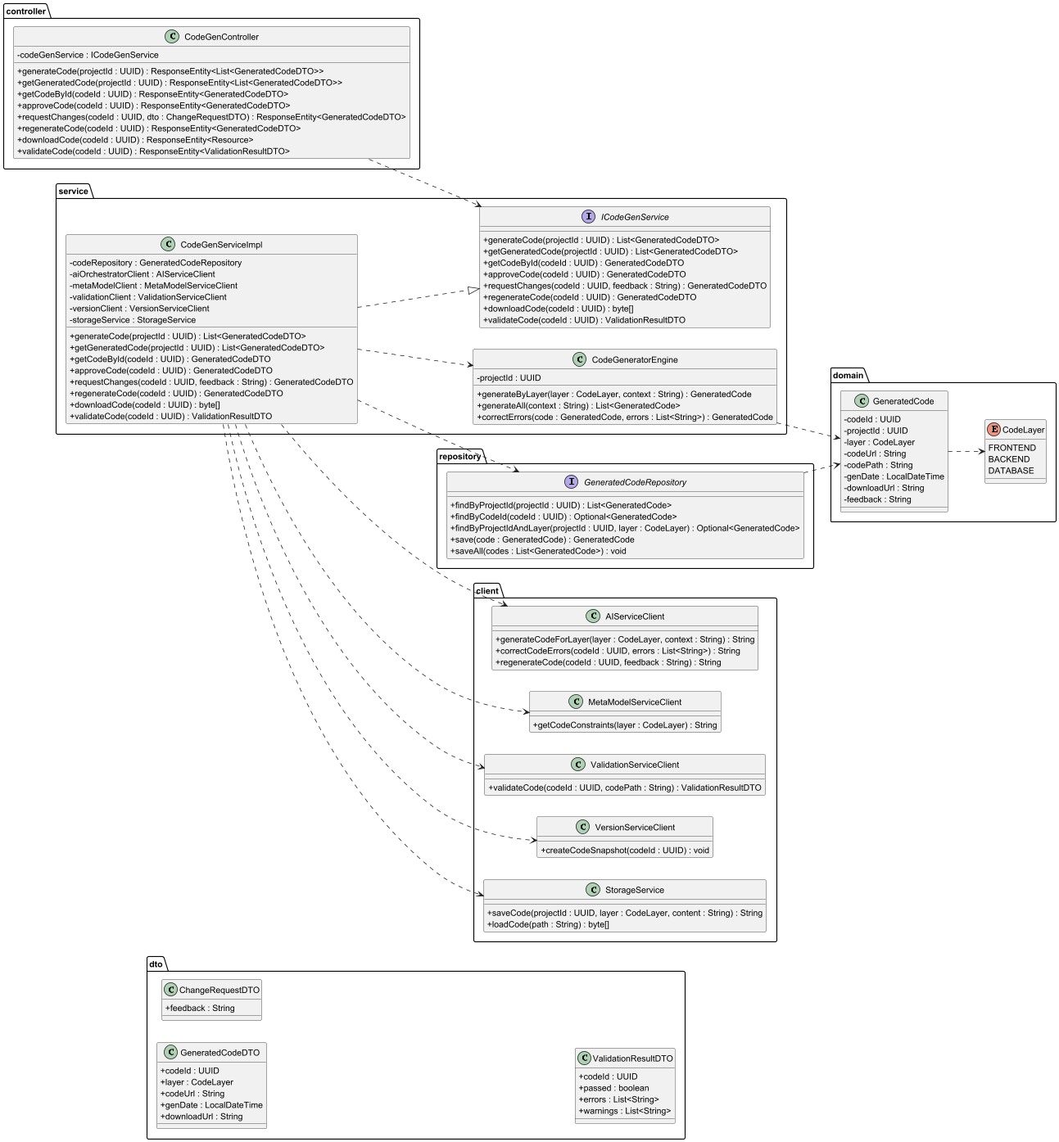
Figure 7: Codegen Class
    - Validation Service
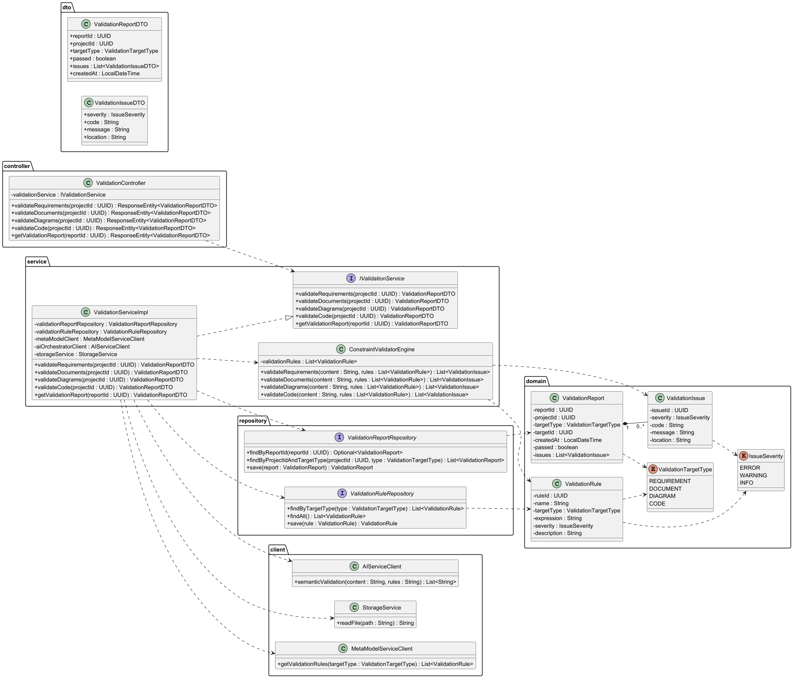
Figure 8: validation service

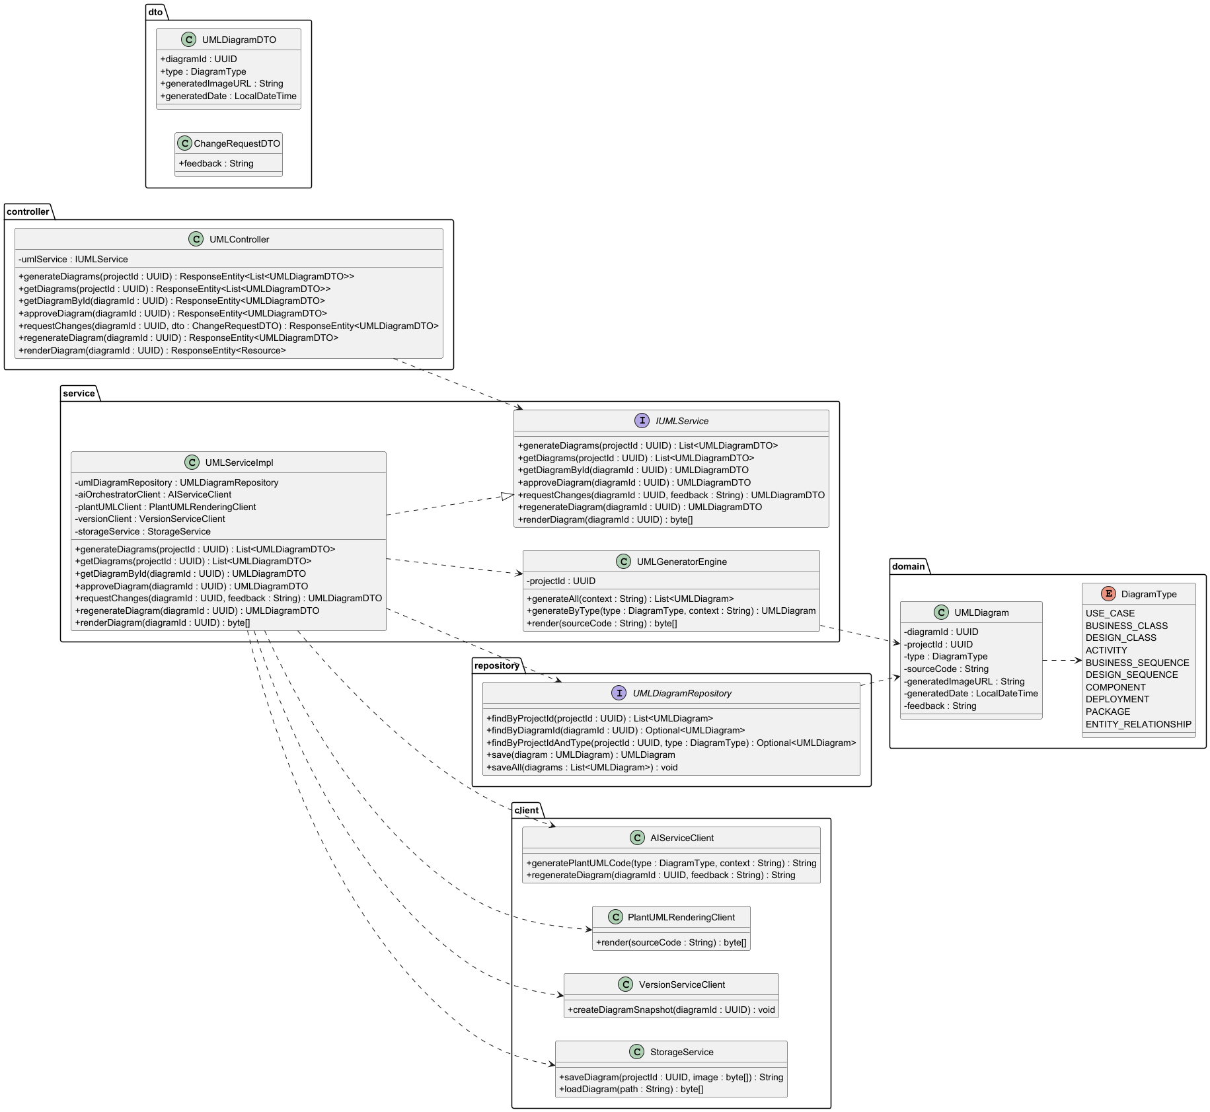
    - PlantUML Rendering Service
Figure 9: UML rendering service class

    - AI Service
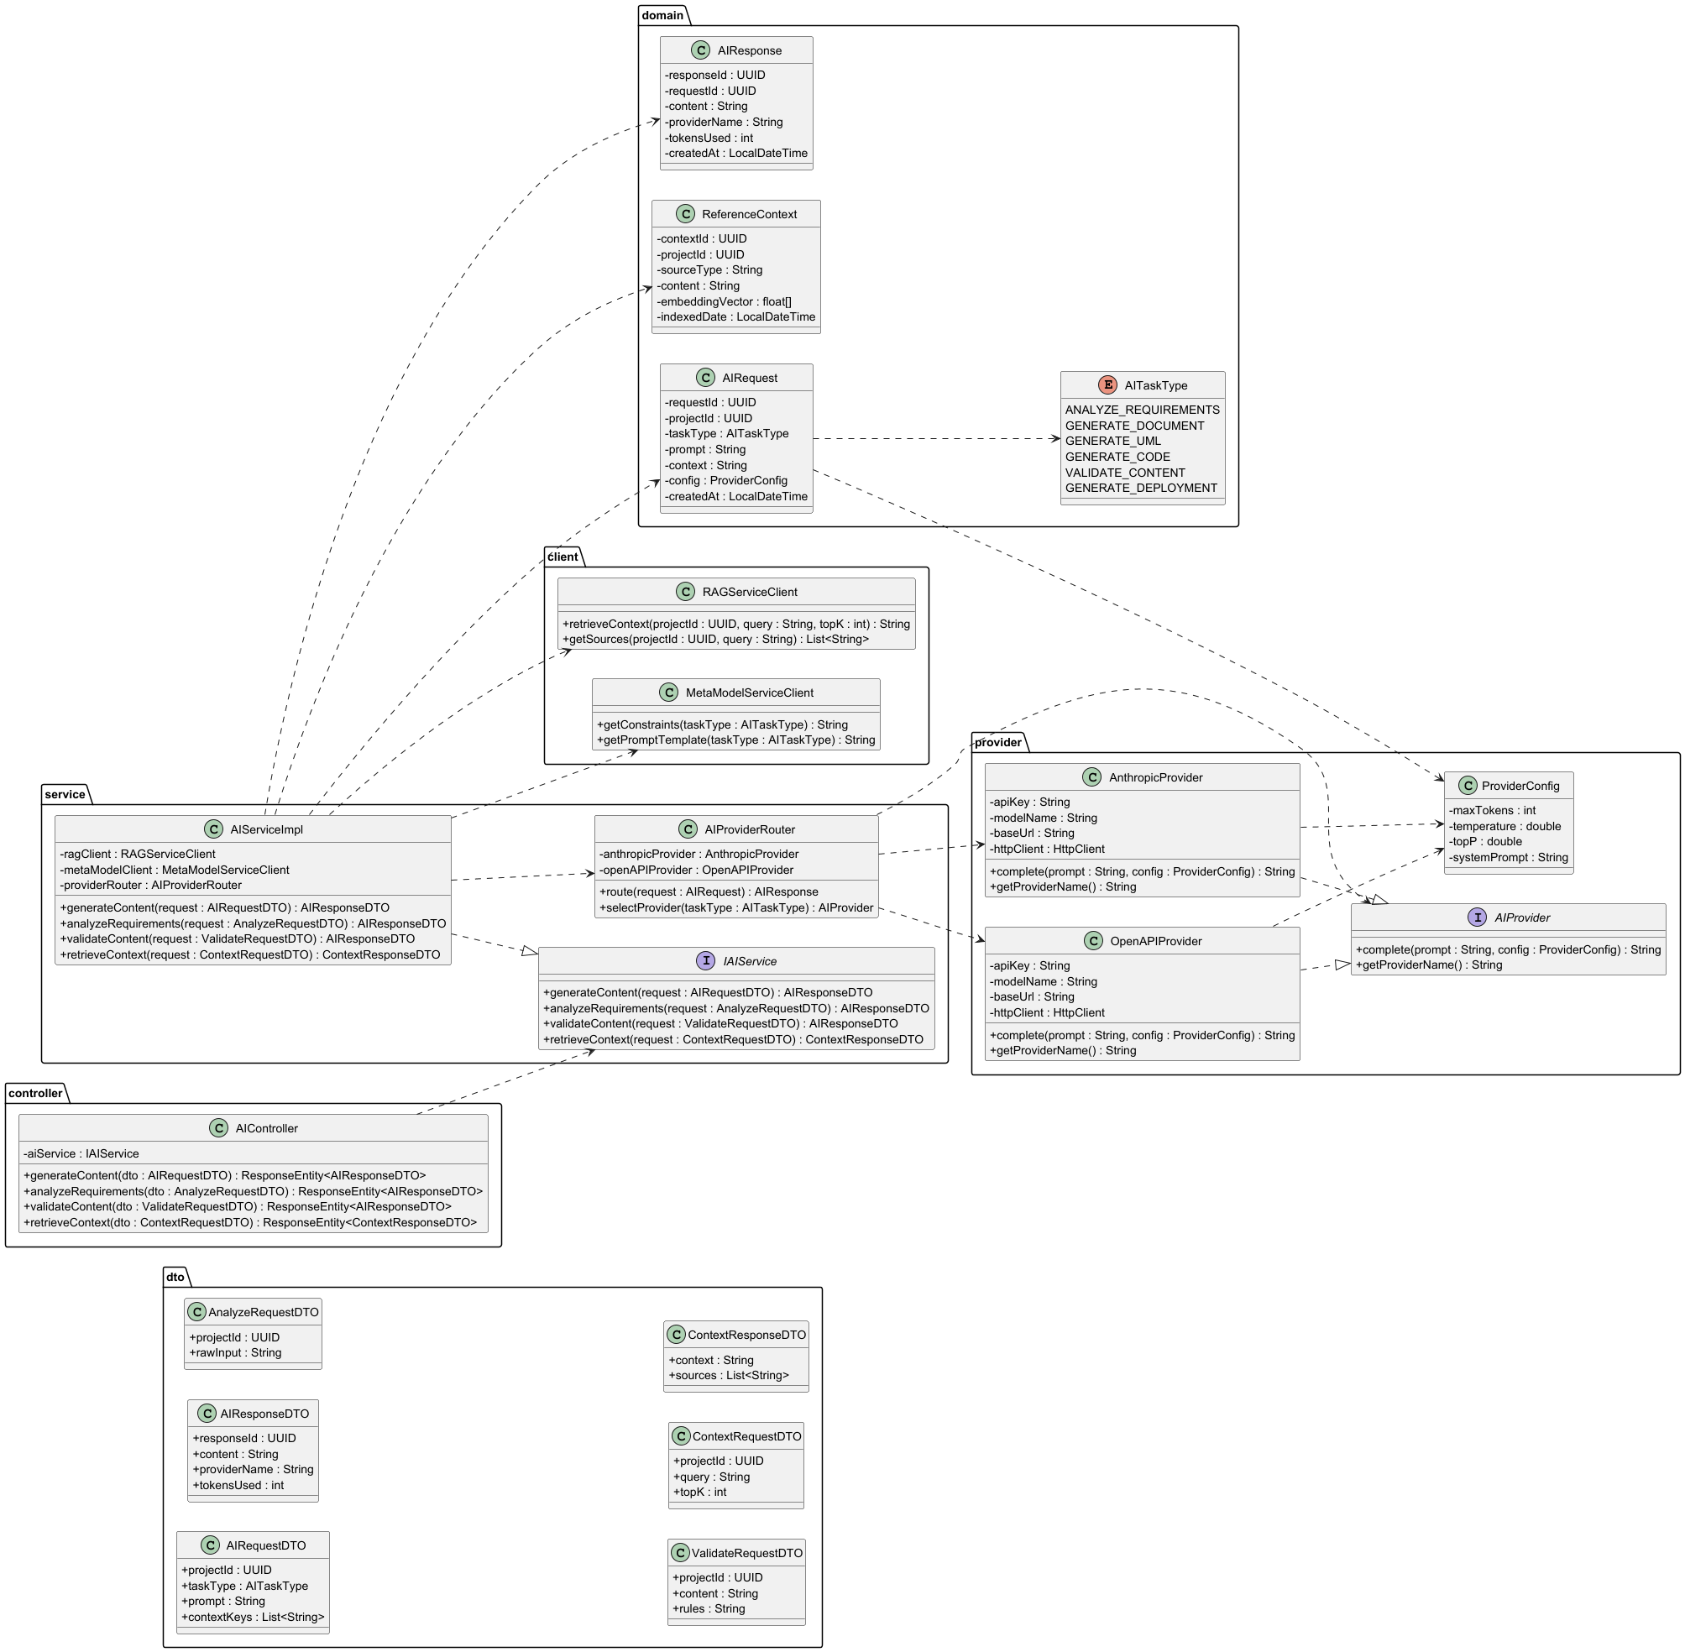
Figure 10: AI orchestrator class

    - RAG Service

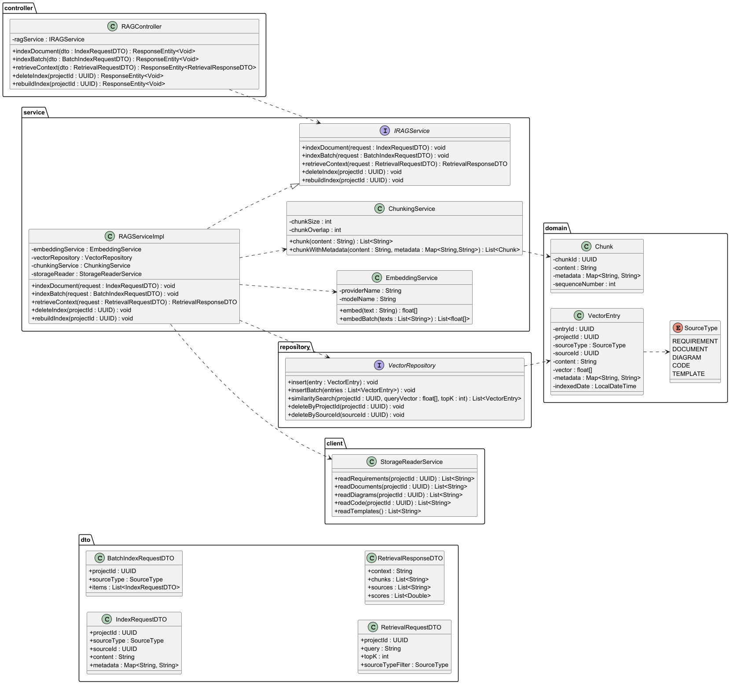
Figure 11: RAG service class

    - Meta Model Service
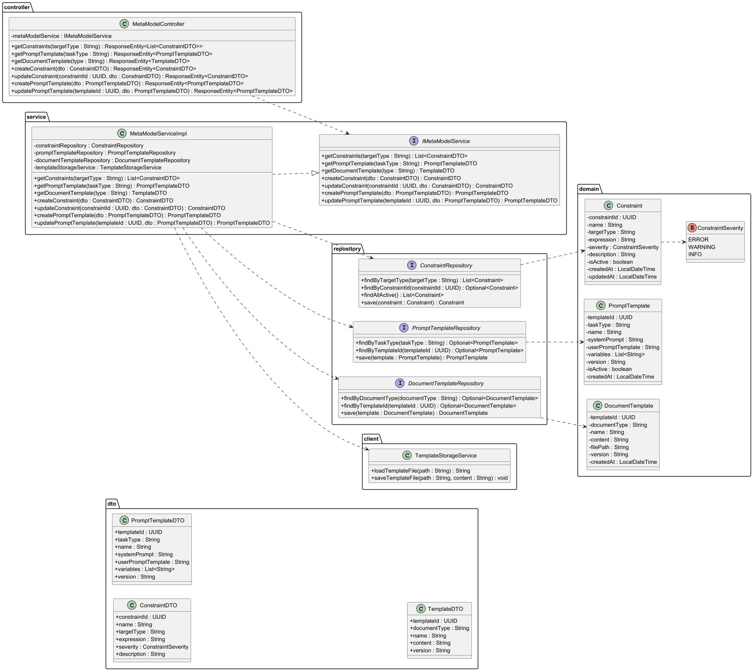
Figure 12: Meta Model service
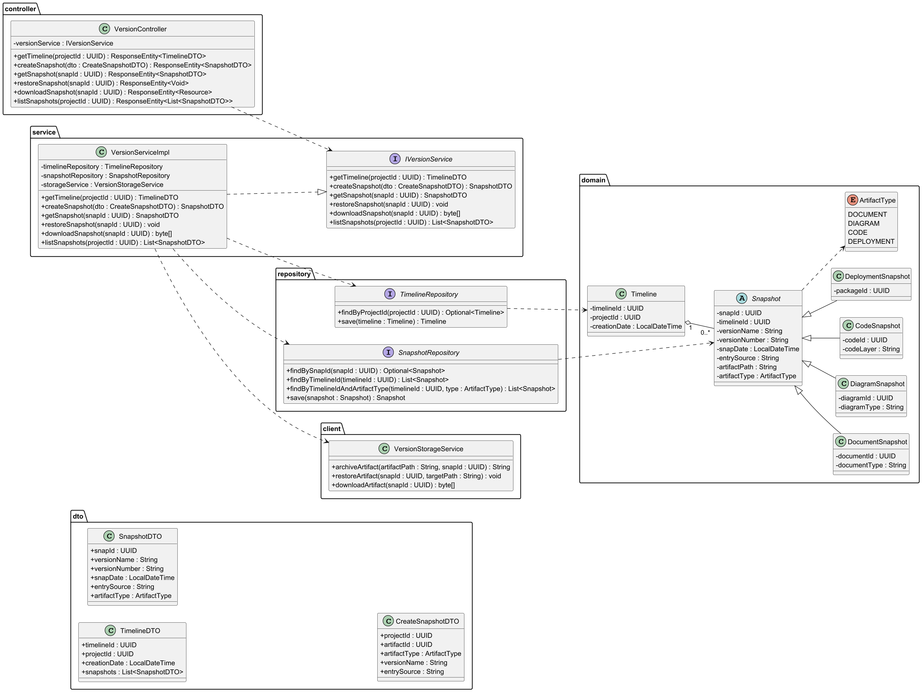
    - Version Managemet service
Figure 13: Meta Model Service Class
Figure 14: Version management service
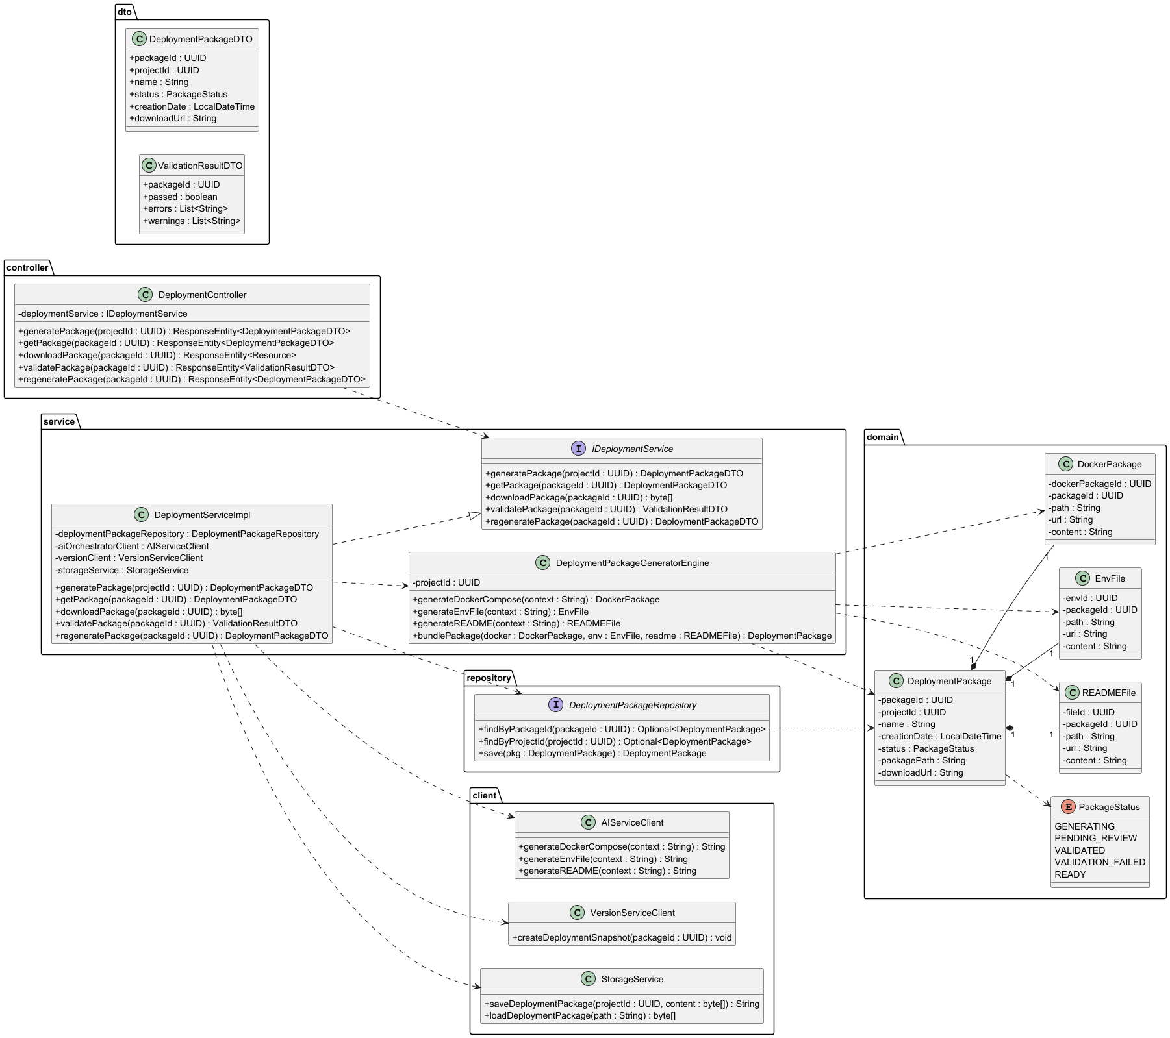
    - Deployment package service
Figure 15: Deployment package service

Sequence Diagrams
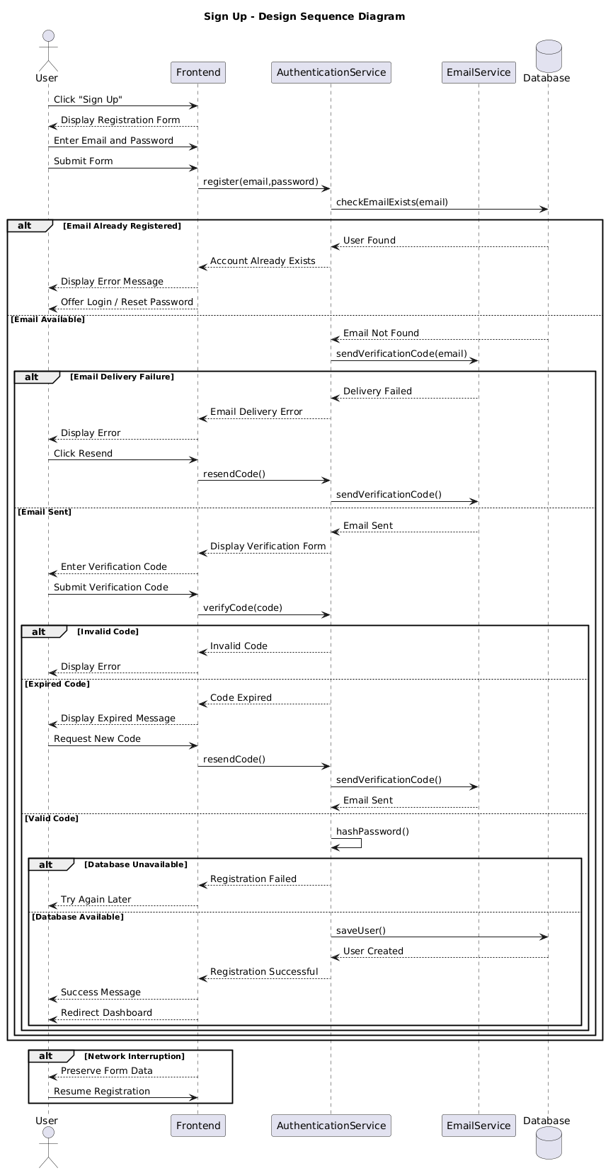
Figure 16: Sign Up Sequence Diagram
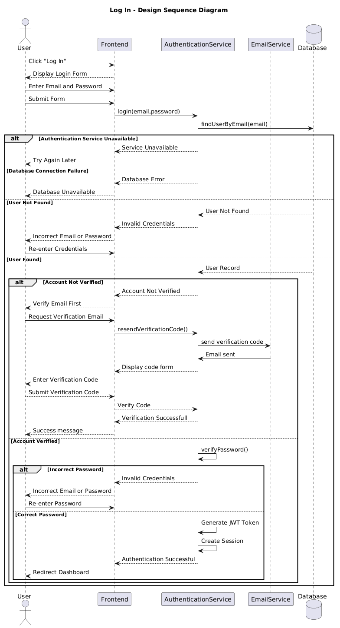
Figure 17: Log In Sequence Diagram
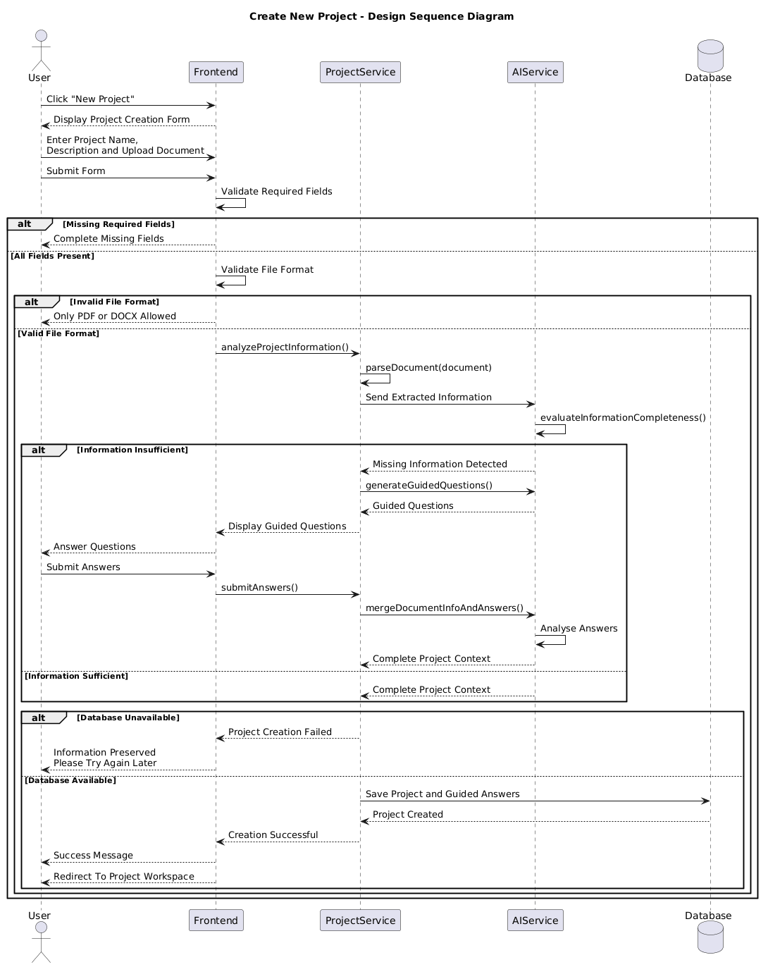
Figure 18: Create Project Sequence Diagram
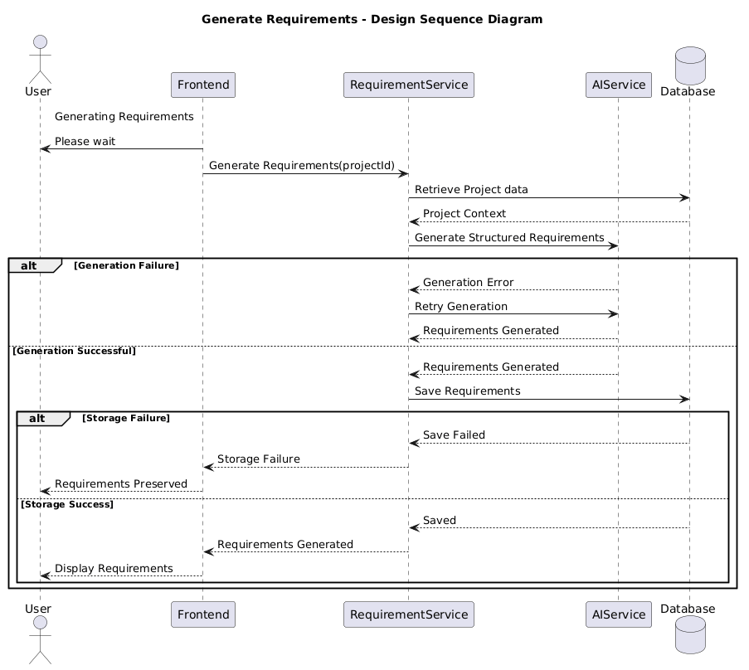
Figure 19: Generate Requirements Sequence Diagram
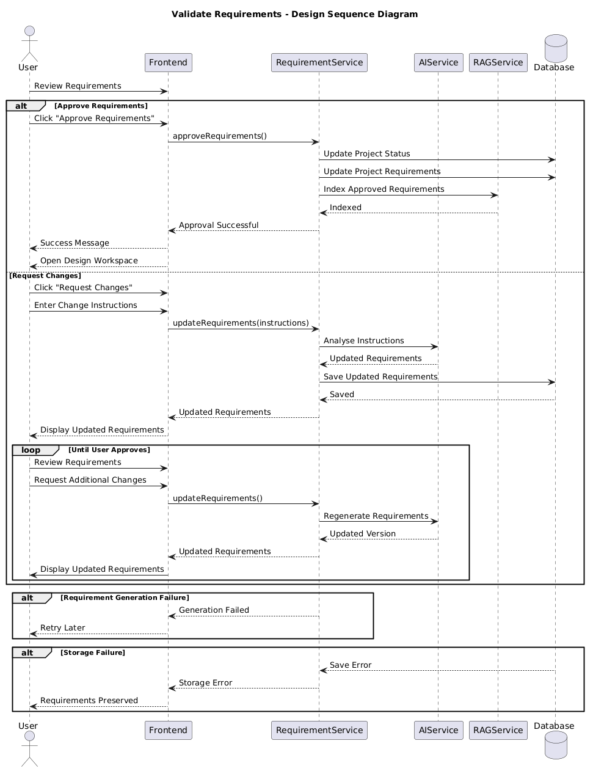
Figure 20: Validate Requirements Sequence Diagram
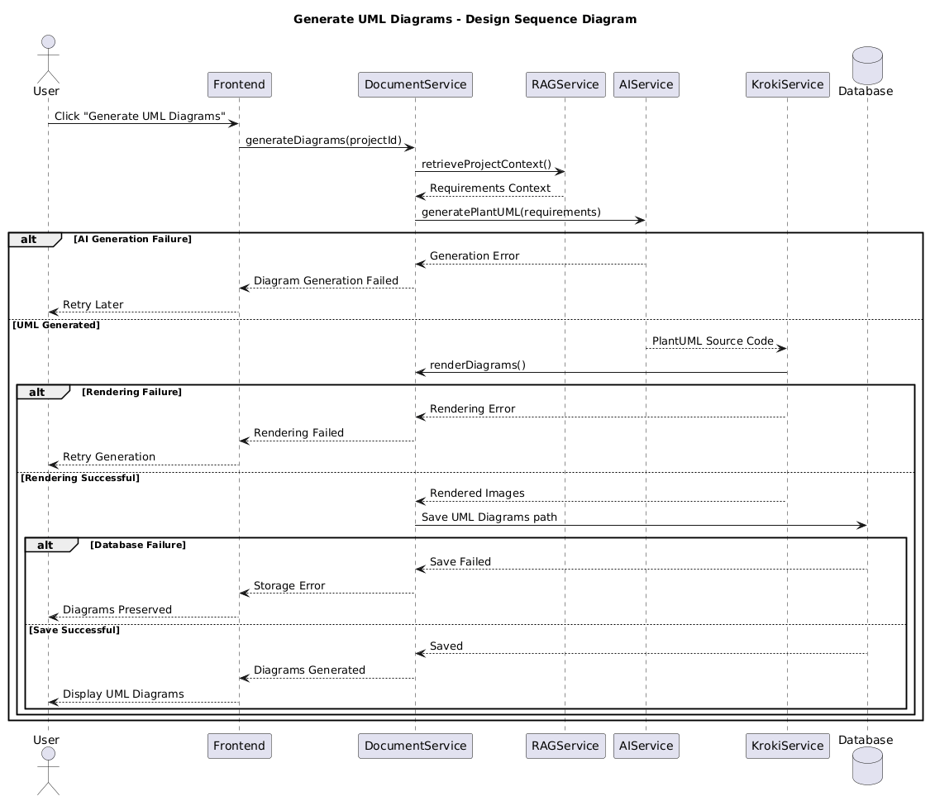
Figure 21: Generate Diagrams Sequence Diagram
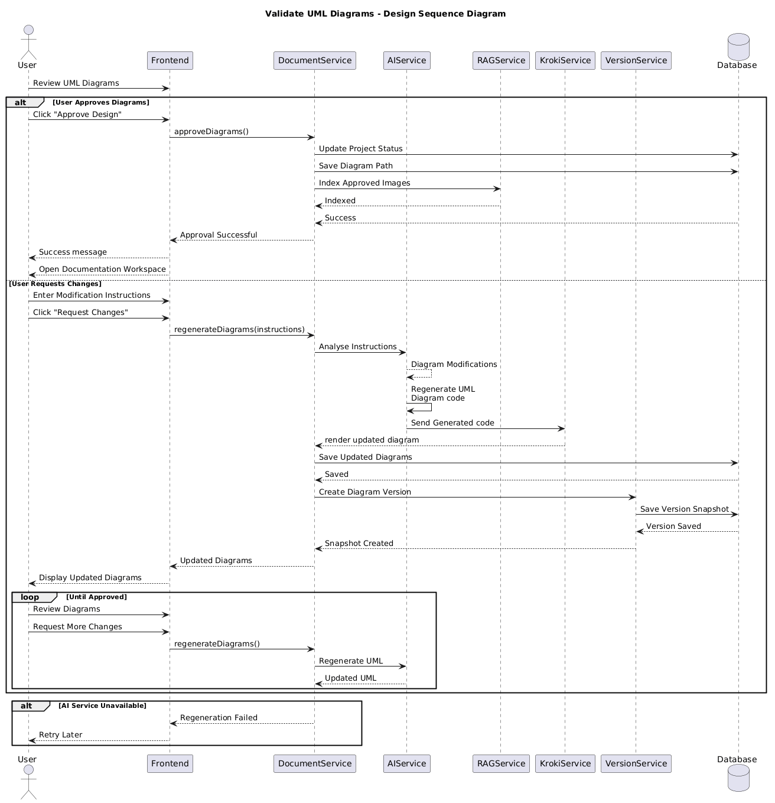
Figure 22: Validate Diagrams Sequence Diagram
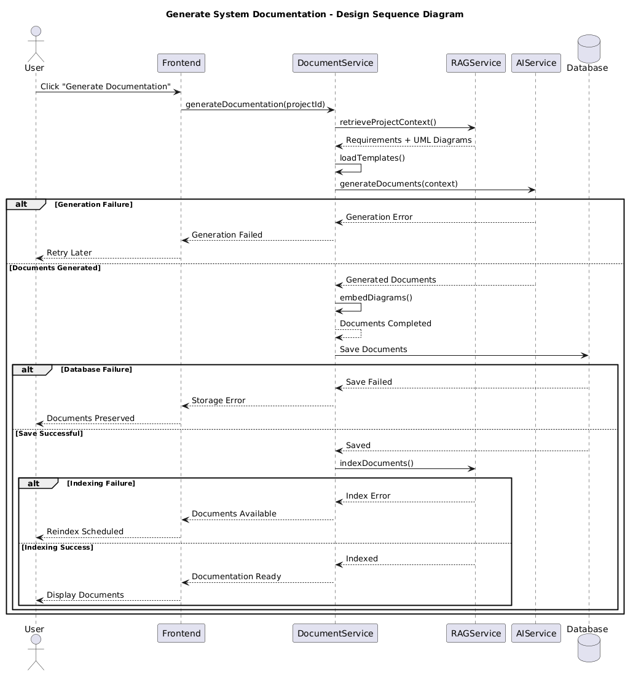
Figure 23: Generate Documentation Sequence Diagram
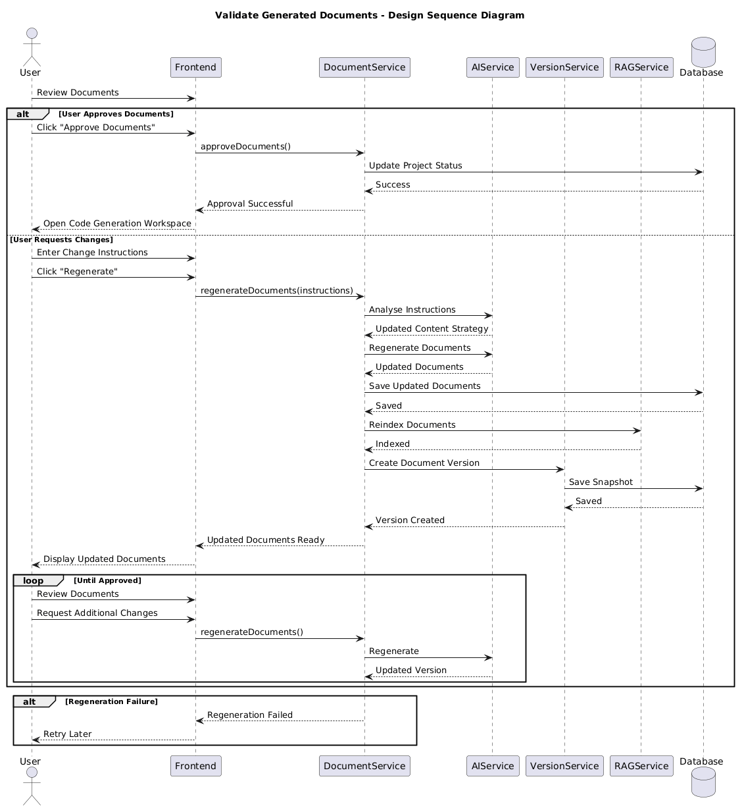
Figure 24: Validate Documentation Sequence Diagram
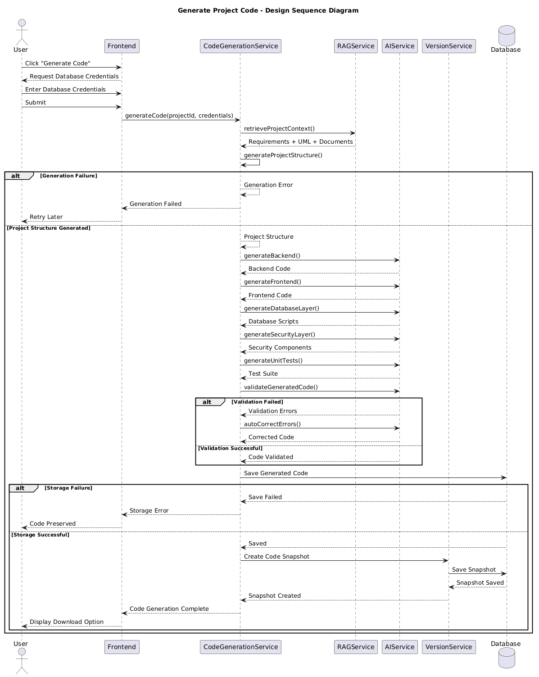
Figure 25: Generate Code Sequence Diagram
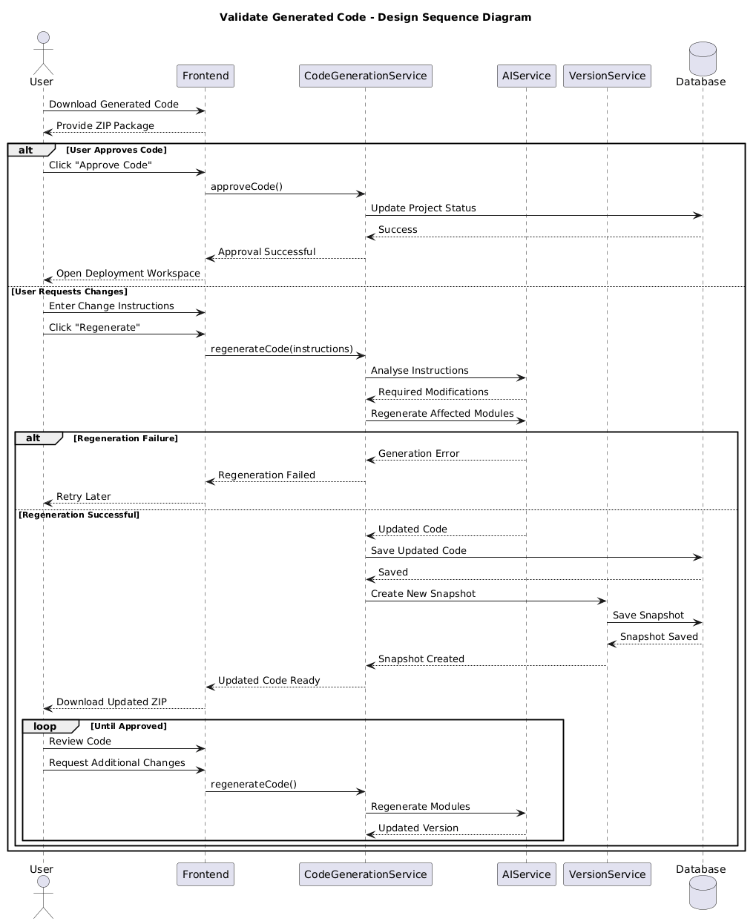
Figure 26: Validate Code Sequence Diagram
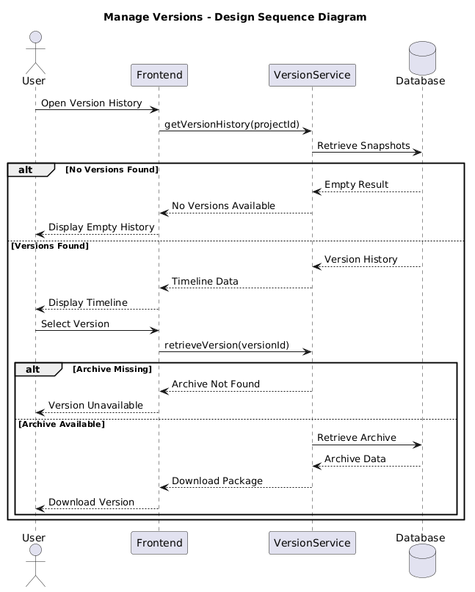
Figure 27: Manage Versions Sequence Diagram
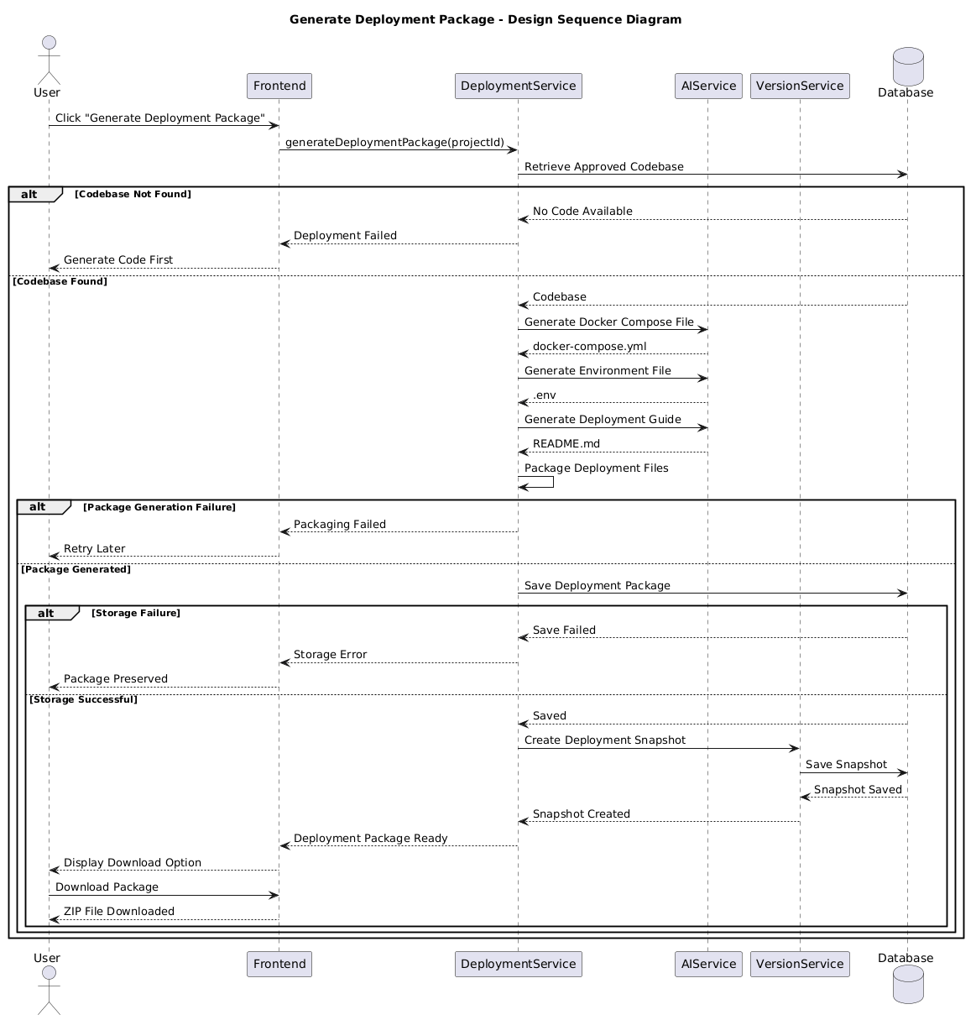
Figure 28: Generate Deployment package Sequence Diagram

Conclusion
This design document has presented the complete technical conception of the platform. Starting from a precise definition of the system objectives and the external interfaces through which the system interacts with its environment, it has established the design constraints that govern all technical decisions. The development standards, tools and quality processes have been clearly identified to provide a solid framework for the development of the platform

